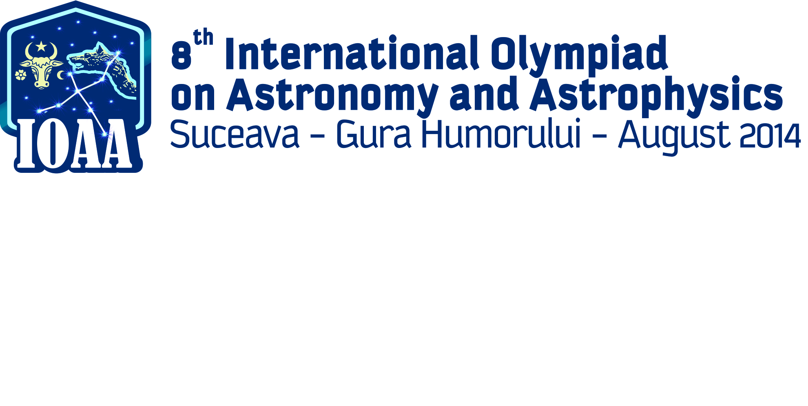

**Content**

Indications 2

16. Long problem 1. Eagles on the Caraiman Cross ! 3

17. Long problem 2. Cosmic Pendulum 4

18. Long problem 3. From Romania …. to Antipod! … a ballistic messenger 6

## Indications

### The problems were elaborated concerning two aspects:

#### To cover merely all the subjects from the syllabus;

#### The average time for solving the items is about 15 minutes per a short problem;

### In your folder you will find out the following:

#### Answer sheets

#### Draft sheets

#### The envelope with the subjects in English and the translated version of them in your mother tongue;

### The solutions of the problems will be written down only on the answer sheets you receiveon your desk. **PLEASE WRITE ONLY ON THE PRINTED SIDE OF THE PAPER SHEET. DON’T USE THE REVERSE SIDE**. The evaluator will not take into account what is written on the reverse of the answer sheet.

### The draft sheets is for your own use to try calculation, write some numbers etc. BEWARE: These papers are not taken into account in evaluation, at the end of the test they will be collected separately . Everything you consider as part of the solutions have to be written on the answer sheets.

### Each problem have to be started on a new distinct answer sheet.

### On each answer sheet please fill in the designated boxes as follows:

#### In **PROBLEM NO**. box write down only the number of the problem: i.e. 1 – 15 for short problems, 16 – 19 for long problems. Each sheet containing the solutions of a certain problem, should have in the box the number of the problem;

#### In **Student ID** – fill in your ID you will find on your envelope, consisted of 3 leters and 2 digits.

#### In page no. box you will fill in the number of page, starting from 1. We advise you to fill this boxes after you finish the test

### We don’t understand your language, but the mathematic language is universal, so use as more relationships as you think that your solution will be better understand by the evaluator. If you want to explain in words we kindly ask you to use short English propositions.

### Use the pen you find out on the desk. It is advisable to use a pencil for the sketches.

### At the end of the test:

#### Don’t forget to put in order your papers;

#### Put the answer sheets in the folder 1. Please verify that all the pages contain your ID, correct numbering of the problems and all pages are in the right order and numbered. This is an advantage of ease of understanding your solutions.

#### Verify with the assistant the correct number of answer sheets used fill in this number on the cover of the folder and sign.

#### Put the draft papers in the designated folder, Put the test papers back in the envelope.

#### Go to swim

**GOOD LUCK !**

# 1. Eagles on the Caraiman Cross !

In the Bucegi mountains, part of the Carpathian mountains, after the end of the First World War an iron cross was built by the former King of Romania called Ferdinand the I-st and his wife Queen Maria. The cross is an unique monument in Europe. The monument is an impressive iron cross called „The Heros’ Cross” which in 2013 entered in the Guiness Book as the cross build on the highest altitude mountain peek.

The cross was built on the plane plateau situated on the top of the peek called Caraiman, at the altitude  from sea level. Its height, including the base-support is . The horizontal arms of the cross are oriented on the N-S direction. The latitude of the Cross is 

A. In the evening of 21st of March 2014, the summer equinox day, two eagles stop from their flight, first near the monument, and the second, on the top of the Cross as seen in figure 1. The two eagles are on the same vertical direction. The sky was very clear, so the eagles could see the horizon and observe the Sun set. Each eagle start to fly right in the moment that each of it observes that the Sun completely disappears.

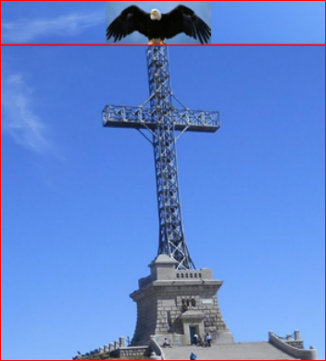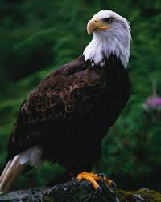

N

S

*h*

Figure 1

In the same time, an astronomer located at the sea-level, at the base of the Bucegi Mountains. Assume that he is on the same vertical with the two eagles.

Assuming negligible the atmospheric refraction, solve the following questions:

**1)** *Calculate* the duration of the sunset, measured by the astronomer.

**2)** *Calculate* the durations of sunset measured by each of the two eagles and indicate which of the eagles leaves first the Cross. What is the time interval between the leaving moments of the two eagles.

*The following information is necessary*:

The duration of the sunset measurement starts when the solar disc is tangent to the horizon line and stops when the solar disc completely disappears.

The Earth’s rotation period is , the radius of the Sun , Earth – Sun distance , the local latitude of the Heroes Cross .

**B)** At a certain moment of the next day, 22nd March 2014, the two eagles come back to the Heroes Cross. One of the eagles lands on the top of the vertical pillar of the Cross and the other one land on the horizontal plateau, just in the end point of the shadow of the vertical pillar of the Cross.

**1)** Calculate the distance between the two eagles, if this distance has the minimum possible value.

**2)** Calculate the length of the horizontal arms of the Cross  if the shadow on the plateau of one of the arm of the cross has the length 

**C)** At midnight, the astronomer visit the cross and, from the top of it, he identifies a bright star at the limit of the circumpolarity. He named this star „Eagles Star”. Knowing that due to the atmospheric refraction the horizon lowering is , calculate:

**1)** The “Eagles star” declination;

**2)** The “Eagles star” maximum height above the horizon.

# 2. Cosmic Pendulum

A space shuttle (N) orbits the Earth in the equatorial plane on a circular trajectory with radius *r.* From the spaceship. The shuttle has an arm designated to place satellites on the orbit. The arm is a metallic rod (negligible mass) with length *.* The arm is connected to the shuttle with frictionless mobile articulation. A satellite **S** is attached to the arm and let out from the shuttle. At a certain moment the angle between the rod and the shuttle’s orbit radius is , see figure 1. You know the mass of the Earth –**M** , and the gravitational constant **G**.





Ecuatorial plane

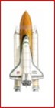



Space shuttle

(N)

Satelite

(S)

Earth

**Fig.2**

1. Find out the values of angle  for which the configuration of the system shuttle – rod –satellite remains unchanged regardless to Earth (the system is in equilibrium), during orbiting the Earth. For each found value of angle, specify the type of the system equilibrium i.e. stable or unstable.

You will take in to account the following assumptions: the initial orbit of the shuttle is not affected by the presence of the satellite **S**, all the external friction-type interactions are negligible, the satellite – shuttle gravitational interaction is negligible too. The following data are known: ,  - the mass of the shuttle, the mass of the satellite .

1. In the moment of one stable equilibrium configuration, the rod with the satellite attached is slightly rotated with a very small angle in the orbital plane and then released. Demonstrate that the small oscillations of the satellite **S** relativeto the shuttle are harmonically ones. Express the period of this cosmic pendulum as a function of the orbiting period T of the shuttle around the Earth.

It is known the linear harmonic oscillator equation:



Where : the instantaneous angular deviation;  the period of the linear harmonic oscillator.

c) If we consider that the mass of the satellite S , m2 is not negligible by comparison with the shuttle’s one m1 in the conditions from point a) the evolution on the orbit of the shuttle would be influenced by the presence of the satellite S rigid attached to the shuttle by the rod. Identify and determine the consequences on the shuttle’s movement after one complete rotation around the Earth.

d) Propose a special technical maneuver which can cancels the influence of the non negligible mass satellite S on the shuttles movement.

# 3. From Romania …. to Antipod! … a ballistic messenger

The 8th IOAA organizers plan to send to the **antipode** the official flag using a ballistic projectile. The projectile will be launched from Romania, and the rotation of the Erath will be neglected.

a) Calculate the coordinates of the target-point if the launch-point coordinates are: 

b) Determine the elements of the launching-speed vector, regardless to the center of the Earth, in order that the projectile should hit the target.

c) Calculate the velocity of the projectile when it hits the target.

d) Calculate the minimum velocity of the projectile.

e) Calculate the flying –time of the projectile, from the launch-moment to the impact one. You will use the value of the gravitational acceleration at Earth surface the Earth radius 

f) Evaluate the possibility that the projectile to be seen with the naked eye in the moment that it passes at the maximum distance from the Earth. You will use the following values: The Moon albedo  The Moon radius ; the Earth –Moon distance km; the apparent magnitude of the full moon  You assume that the projectile is perfectly metallic sphere with radius and with perfectly reflective surface.